**E-ADVOCATE**

303 617 8811 or 785 473 7851 prolaw@prolaw assist.com

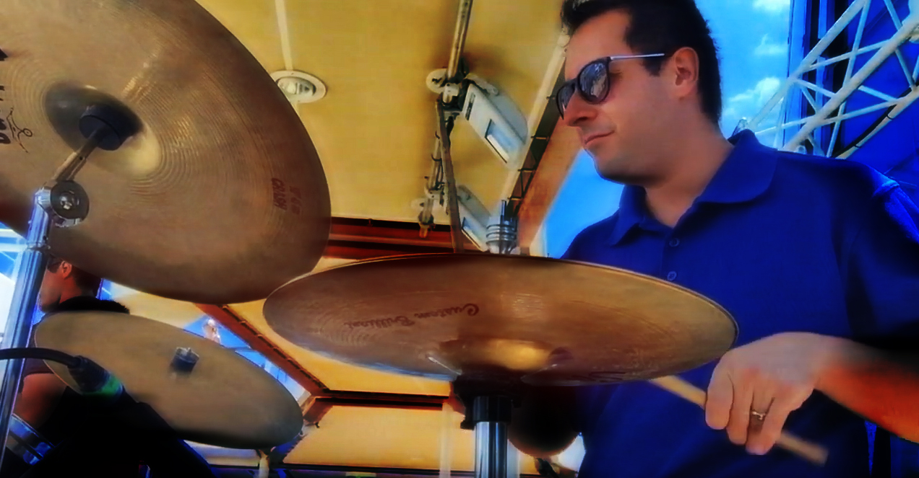

We advocate on behalf of business and consumers. What does that mean? It means: We help businesses and people.

Specifically, the services and products we offer are:

**R**esearch, **E**-Advocacy, **A**uthor, **L**yricist and **M**arketing.

Below is a brief summary of each of our products and services:

*R-Research* We utilize digital global libraries to conduct thorough research on behalf of our clients.

*E-Advocacy* Consumers and businesses often need information. We do all the footwork necessary to obtain qualified answers or recommend practical solutions to disputes. Our work is completed entirely on-line for the convenience of our clients.

*A-Author* We author on-line material including, research, blogs, books, quotations and virtually any business or consumer related content.

*L-Lyricist* We write lyrics for songs ‘tell stories’, collaborate with musicians and businesses interested in utilizing our creative product.

*M-Marketing* We provide marketing expertise to our clients not limited to initiating brands, growing brand recognition and influence, conducting market research, trend analysis and data analytics. Our expertise enables us to support business and consumers desiring to start a business or market products or concepts in preparation of launching an enterprise.

PLEASE NOTE: The word *‘REALM’* is an acronym for our unique virtual (on-line) business model.

If you are trying to solve a dispute or obtain critical information we can help.

Do you have an upcoming special occasion, wedding, reunion, or private party? We provide high quality live music.

Recently, one of our highly regarded professional performers was fortunate to converse with music icon, Frankie Valli after an international cruise ship performance. This quotation is indicative of the highlight:

*‘I learned by listening to other people sing and doing impressions of them. And there are things no one can ever teach you, like phrasing. Like listening to Sinatra, for instance - you felt that everything he sang had happened in his life.’*

*-Frankie Valli*

Let us plan and provide the appropriate ambiance to take your special event or occasion to the next level.

Weddings, anniversaries, special occasions, business, college or university socials; even private parties deserve the quality live performances our artists musicians deliver.

Our artist musicians have extensive experience in the global entertainment industry and live performances with iconic NYC Broadway entertainers.

We provide first-rate live music of every genre. Your guests will leave your event with enduring memories to cherish for a lifetime. And you get all of the credit.

Music lyrics tell stories, interesting, motivating, celebratory, informative and more. There is always an inescapable measure of carefully calculated fun.

We are safety conscious in accordance with existing national, state and local restrictions due to the covid-19 virus pandemic. Distancing, mask wearing and outdoor settings are highly recommended.

While we comprehend the urgency of the current pandemic, solutions are on the horizon. Our entertainment crew will team with your coordinator(s) to ensure a seamless, pragmatic, safe, customized, live music entertainment package suited to your individual needs and preferences.

All live music performance packages are custom designed, especially for you. Recruiting the right musicians, rehearsing and coordinating requires adequate time.

Sufficient advance notice is required. When prospective clients contact us early, we are able to maximize the entertainment experience.

*A good rule of thumb is two to three months advance notice.* Although many live music performances can be done with limited notice and in some cases without notice. Please ask.

Do you have an upcoming event in mind? Don’t delay. Let us join your team. All it takes is a brief email message. If you prefer, tell us when you anticipate your event will occur and include contact information. Or simply leave a message so we can return your call and work out related details. We will respond with utmost urgency.

Real Music, Live!

303 617 8811 or 785 473 7851 [prolaw@prolawassist.com](mailto:prolaw@prolawassist.com)